**Lab 8**

Expt 1: Write a program to create orphan process.



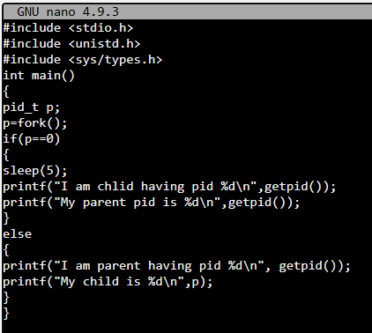

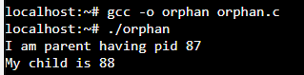

Expt 2: Write a program to create zombie process



